Wednesday, October 7, 2020
Honoring Lynn & Frank Mara and Dr. Julie McNamara

Sponsorship Opportunities

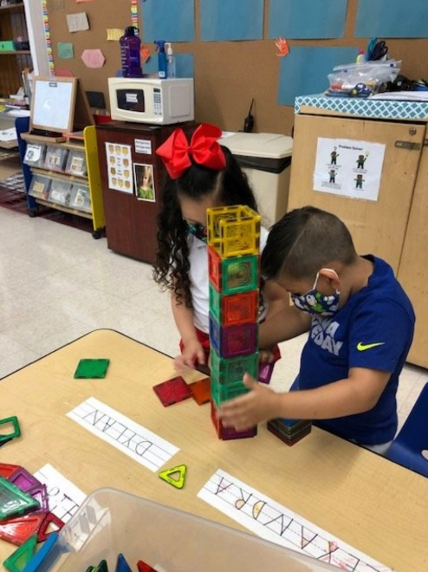

Overview
The Gala supports the mission of Foundations in Education: to strengthen and transform Catholic education in the Diocese of Bridgeport by supporting innovation in academic and extra-curriculum programs, fostering opportunities for the professional development of school leaders in innovation and leadership and providing scholarship assistance to families in need.

Proceeds benefit Foundations in Education including our two principal initiatives – The Bishop’s Scholarship Fund and The Innovation & Leadership Grants Program. The Bishop’s Scholarship Fund provides tuition assistance for over 1,450 children from low-income families including select Leaders of Tomorrow. The Innovation & Leadership Grants Program promotes excellence by providing educators with grant opportunities that fund innovation in the classroom and support for professional development and
leadership formation.

Audience
As a sponsor, your organization will impact the lives of more than 1,450 students who receive financial assistance and 8,000 students enrolled in Catholic schools in Fairfield County. This year, due to the COVID 19 pandemic, our community leaders will come together actually as well as virtually in celebration and support of excellent and accessible Catholic education. Your sponsorship will be promoted online and on social media, as well as in all event materials including recognition in our E-Journal and throughout the virtual program.

Event
Wednesday, October 7, 2020
Bishop’s Former Residence, Trumbull
Invocation, Program and Auction will be streamed virtually beginning at 7:15 p.m.

Honorees
Foundations in Education recognizes excellence in education and generosity in philanthropic support of Catholic education each year. Honorees for the 2020 Spring Gala are Lynn and Francis X. Mara, New York Football Giants, Inc., and Dr. Julia M. McNamara, President Emerita, Albertus Magnus College.

About Foundations in Education
Foundations in Education promotes academic excellence, faith formation and enrollment in Catholic Schools in the Diocese of Bridgeport through tuition assistance for needy children, innovation grants for classroom teaching and transformational leadership grants for faculty and administrators.

Contact
Megan Quinn, Assistant Director of Development, Foundations in Education
203.416.1671 (office) or mquinn@foundationsineducation.org

Sponsorship Opportunities
 | Chairman  Sponsor  $100,000 | Benefactor  Sponsor  $50,000 | Champion  Sponsor  $25,000 | Patron  Sponsor  $15,000 | Corporate Partner  $10,000
Students Impacted* | 40 | 20 | 10 | 6 | 4
Host Package (bottle of wine and 10 dinners delivered to your locale within 25 miles) | Yes | Yes | Yes | Yes
Recognition during Virtual Program | Yes | Yes | Yes | Yes
Link to Virtual Program and Auction | Yes | Yes | Yes | Yes | Yes
E-Journal Recognition | Yes | Yes | Yes | Yes | Yes
Foundations in Education Website Recognition | Yes | Yes | Yes | Yes | Yes
Recognition in Fairfield County Catholic | Yes | Yes | Yes | Yes | Yes
* Based on average half scholarship

E-Journal
All ads will be displayed in an elegant journal slide show during the event.
Platinum Ad Full Screen $5,000
Gold Ad Half Screen $3,000
Silver Ad Quarter Screen $1,500
Bronze Ad Business Card $500

Due date for Ad Submissions is Wednesday, September 16, 2020.

Please contact Foundations in Education at 203.416.1671 for specific formats for your art work and ad.
Commitment Form

Sponsorship Levels Sponsorship Information

- Chairman $100,000 Name ___________________________________________
- Benefactor $50,000 (As you would like it to appear in event materials)
- Champion $25,000 Contact Name __________________________________
- Patron $15,000 Address __________________________________________
- Corporate $10,000 City __________________State ______ Zip ___________
Partner Phone _____________________Fax __________________
Email ____________________________________________
E-Journal
- One Sponsor Ticket to Virtual Program
$1,000
- One Ticket to Virtual Program
$500

- Platinum Ad – Full Screen $5,000
- Gold Ad – Half Screen $3,000
- Silver Ad – Quarter Screen $1,500
- Bronze Ad – Business Card $500

- We are unable to participate, but would like to make a contribution in the amount of $_________________

- I plan to have my donation matched with a corporate matching gift!
Please ask your employer for a matching gift form and return completed form to Foundations in Education.

For tax purposes, the benefit portion of your contribution is estimated at $150 per attendee.
Net proceeds from the Gala support Foundations in Education, Inc.

Payment Method

Check (payable to Foundations in Education)
Credit Card
Credit Card Number ______________________________________________________________________
Expiration Date ______________________________________________________________________
Auth. Code _______________________________________________________________________
Signature _________________________________________________________________________

Total Amount $_____________________________________________________________________
Your sponsorship is requested by Wednesday, September 16, 2020.

Please send this Commitment Form along with your check or credit card information to:

Foundations in Education ● 238 Jewett Avenue ● Bridgeport, CT 06606

